Linux Programming LAB Week-8 19R21A0568 A. Narsimha Dhangar

# Write a C program for client server communication and print the message ? Program :

**server.c** #include<stdio.h> #include<netinet/in.h> #include<stdlib.h> #include<sys/socket.h> #include<sys/types.h>

int main(int argc,char const* argv[]){

int servSockD = socket(AF_INET,SOCK_STREAM,0);

char serMsg[255]= "Message from server to the" " client\'Hello Client\' "; struct sockaddr_in servAddr;

servAddr.sin_family = AF_INET; servAddr.sin_port = htons(9001); servAddr.sin_addr.s_addr = INADDR_ANY;

bind(servSockD, (struct sockaddr*) & servAddr , sizeof(servAddr)); listen(servSockD,1);

int clientSocket = accept(servSockD,NULL,NULL); send(clientSocket,serMsg,sizeof(serMsg),0); return 0;

}

**client.c** #include<stdio.h> #include<netinet/in.h> #include<stdlib.h> #include<sys/socket.h> #include<sys/types.h>

int main(int argc,char const* argv[]){

int sockD = socket(AF_INET,SOCK_STREAM,0); struct sockaddr_in servAddr;

servAddr.sin_family = AF_INET; servAddr.sin_port= htons(9001); servAddr.sin_addr.s_addr= INADDR_ANY;

int connectStatus = connect(sockD,(struct sockaddr*)&servAddr,sizeof(servAddr)); if(connectStatus == -1){

printf("Error...\n");

}

else{

char strData[255]; recv(sockD,strData,sizeof(strData),0); printf("Message:%s\n",strData);

}

return 0;

}

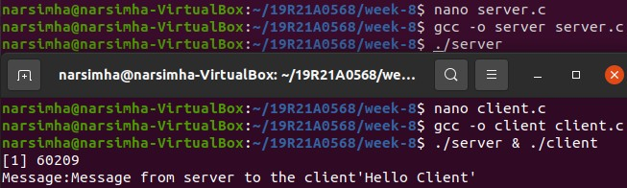

# Write a C program that illustrates semaphore ? Program:

#include<stdio.h> #include<unistd.h> #include<sys/types.h> #include<sys/ipc.h> #include<sys/sem.h> int main()

{

int semid; char a='5';

semid=semget((key_t)3,1,IPC_CREAT|0666); if(semid==-1)

printf("Error in creating semaphore\n"); semctl(semid,0,SETVAL,6);

struct sembuf sem_op; FILE *fd; fd=fopen("mlrit.txt","a"); sem_op.sem_num=0; sem_op.sem_op=-1; sem_op.sem_flg=0; semop(semid,&sem_op,1); putc('\n',fd);

putc(a,fd); putc('\n',fd); fclose(fd);

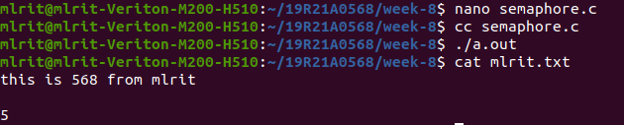}

# Write a C program that illustrates the message queues with a sender and receiver ?

**Program:**

# sender.c

#include <stdio.h> #include <sys/ipc.h> #include <sys/msg.h> #include <string.h> #include <stdlib.h> struct mesg_buffer {

long mesg_type; char mesg_text[100];

} message; int main(){

key_t key; int msgid;

key = ftok("progfile", 65);

msgid = msgget(key, 0666 | IPC_CREAT); message.mesg_type = 1;

printf("Write Data : "); gets(message.mesg_text);

msgsnd(msgid, &message, sizeof(message), 0); printf("Data send is : %s \n", message.mesg_text); return 0; }

# receiver.c

#include <stdio.h> #include <sys/ipc.h> #include <sys/msg.h> struct mesg_buffer {

long mesg_type; char mesg_text[100];

} message; int main() {

key_t key;

int msgid;

key = ftok("progfile", 65);

msgid = msgget(key, 0666 | IPC_CREAT); msgrcv(msgid, &message, sizeof(message), 1, 0); printf("Data Received is : %s \n",message.mesg_text); msgctl(msgid, IPC_RMID, NULL);

return 0; }

